Book or Article Title. | Suitable age or year group. | Why it is recommended.
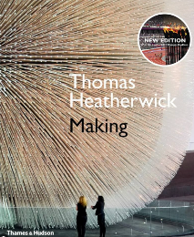  Making by Thomas Heatherwick | Year 10 and 11 | A fabulous book full of amazing ideas to inspire students.
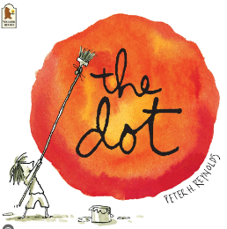  The Dot. By Peter H Reynolds. | All ages | A book about creativity and resilience.
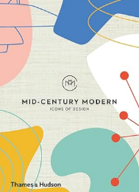  Mid-Century Modern Icons of Design. | All ages | An accessible reference book introducing students to produce design and iconic designers.
Online article:  Meet 20 of the most famous product designers of all time (so far) | All ages | https://designwanted.com/10-most-influential-product-designers/  A list of 20 of the most influential product designers.

