**BROOK GREEN**

**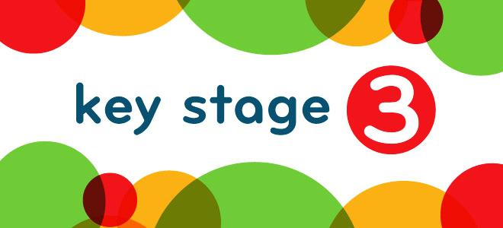**

**All the important bits you need to know**

**2023 - 2024**

**The School Day**

Our school day starts at 8.45 am and finishes at 3.00pm

8.45am – 9.00am Breakfast and Tutor time

9.00am – 9.45am Lesson one

9.45am – 10.30am Lesson two

10.30am – 11.15am Lesson three

11.15am – 11.30am Breaktime

11.30am – 12.15pm Lesson four

12.15am – 1.00pm Lesson five

1.00pm – 1.30pm Lunchtime

1.30pm – 2.15pm Lesson six

2.15pm – 2.55pm Lesson seven

2.55pm – 3.00pm Getting ready for transport



**The Curriculum**

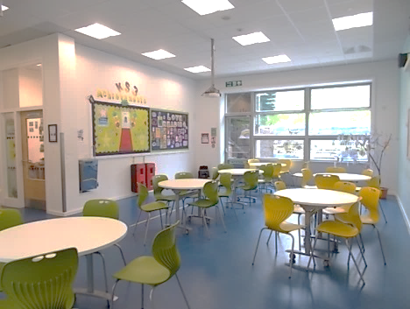

 We cover the following core curriculum

subjects that are delivered in mainstream

settings at Key Stage Three:

Maths (Ma)

English (En)

Science (Sc)

Humanities (Hu)

Music (Mu)

Art (At)

Drama (Dr)

Food Technology (Tf)

Technology (Te)

French (Mf)

Citizenship (Ps)

PE and Games (PE / Ga)

Computing (It)

Building Blocks (BB)

Learning Outdoors (LO)

(The letters in brackets are the ones we use on timetables.)

**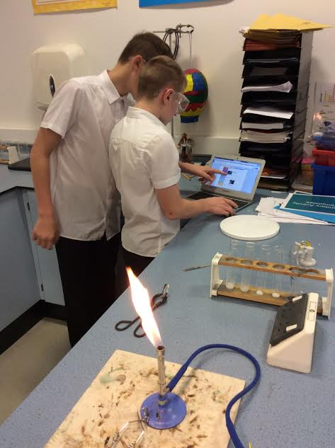Rewards**

For Friday afternoon activities we use Sleuth, which is a Behaviour Management tracking system. At the end of each lesson traffic lights are used as part of the plenary covering the following areas:

|  |  |  |  |  |
| --- | --- | --- | --- | --- |
| **Behaviour** | **On Task** | **Progress** | **Respect** | **Listening** |
| I have not behaved well this lesson | I have not stayed on task this lesson | I have not made any progress in any part of the lesson | I have not shown respect during the lesson | I have chosen not to listen in any part of the lesson |
| I have behaved for ***most*** of the lesson | I have stayed on task for ***most*** of the lesson | I have made ***some*** progress during the lesson but not as much as I could have | I have been kind and respectful to everyone for ***most*** of the lesson | I have listened for ***most*** of the lesson |
| I have been on my best behaviour  ***all*** lesson | I have stayed on task ***all*** lesson | I have made progress in the lesson to the best of my ability | I have been kind and respectful to everyone ***all*** lesson | I have listened ***all*** lesson and  used ‘Tools for Talk’ |

The total number of reds, ambers and greens are calculated and students can choose from a range of staff led activities on a Friday afternoon depending on their score for the week.

There is also reflection for those students who need some time to look at how their behaviour and learning has been during the week to support them and discuss strategies for the following week.

**Celebrating our Achievements**

It is also really important for us the celebrate the achievements of our whole school community and every term we have a Rewards assembly which awards certificates and prizes for Attendance, being a Literacy Legend, School Ambassador or getting a Governor’s Award and lots of other achievements.



****

Wind

Earth



Water

Fire

Each student belongs to a House: Wind, Earth, Fire or Water. The students gain House points for a range of positive achievements such as when they improve their social skills, being respectful, 100% attendance, values…

They can also gain House points during Intra-Sport tournaments that take place at the end of every term.

The House points are recorded on an individual and team level. Students can choose to spend their House Points on small prizes or save them for bigger ones.

The winning House is awarded a House Trophy termly with their House colour; it has pride of place on display for all to see.

**P.E**

# C:\Users\toribalsdon\Downloads\IMG_0701.JPG

# 

We further encourage our students to regularly take part in physical activity by running extra- curricular clubs on Thursdays and opening the sports hall at lunchtimes, providing more supervised activity sessions. Alongside this, we engage in a healthy Inter-School programme which involves regular Football tournaments at Goals and other sporting activities such as tennis, basketball and swimming.

# [Image result for pe clipart](https://www.google.co.uk/url?sa=i&rct=j&q=&esrc=s&source=images&cd=&cad=rja&uact=8&ved=2ahUKEwiN_uqGwefbAhVKPhQKHc92CjgQjRx6BAgBEAU&url=https://clipartxtras.com/categories/view/e5da5487c14ece40c5f24a765b07faa06ae8f75b/pe-clipart.html&psig=AOvVaw0dGmbpSioKz2PoBLkhaTia&ust=1529765046523840)

[](http://www.google.co.uk/url?sa=i&rct=j&q=&esrc=s&source=images&cd=&cad=rja&uact=8&ved=2ahUKEwiOvY2p7fXbAhXFxRQKHU0_Ap0QjRx6BAgBEAU&url=http://clipartmag.com/eat-healthy-clipart&psig=AOvVaw19f-H8MZ8BfcStzeyXuPWz&ust=1530257611525631)[](http://www.google.co.uk/url?sa=i&rct=j&q=&esrc=s&source=images&cd=&cad=rja&uact=8&ved=2ahUKEwjhhY_t7PXbAhUM6xQKHcu0DZwQjRx6BAgBEAU&url=http://al-taiclub.com/explore/apple%20food%20clipart/&psig=AOvVaw19f-H8MZ8BfcStzeyXuPWz&ust=1530257611525631)

**Healthy Eating**

AT BGCfL, our aim is to ensure food and healthy eating is covered through a whole school approach, engaging students, parents/carers, teachers and governors to develop a shared responsibility for food in our school. We actively encourage the students to eat healthy snacks at break times and to drink plenty of water during the school day. In Food Technology, Mrs Wenmoth teaches students about healthy and well balanced diets and how to prepare a wide variety of meals from scratch using fresh ingredients rather than ready-made sauces.

KS3 enjoy growing fruit and vegetables from the school ground. The Life Skills group in KS4 and learning in the environment carry out most of the work so all the students help with this. Mrs Wenmoth and Mrs Taylor then use the produce to cook with students or Mrs Wenmoth makes a variety of jams, pickles and chutneys to sell at various events throughout the academic year.

# C:\Users\toribalsdon\Downloads\AR-140509796.jpgBuilding Blocks

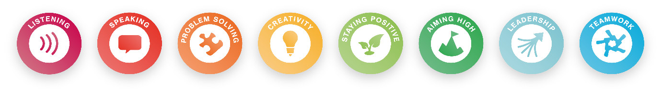

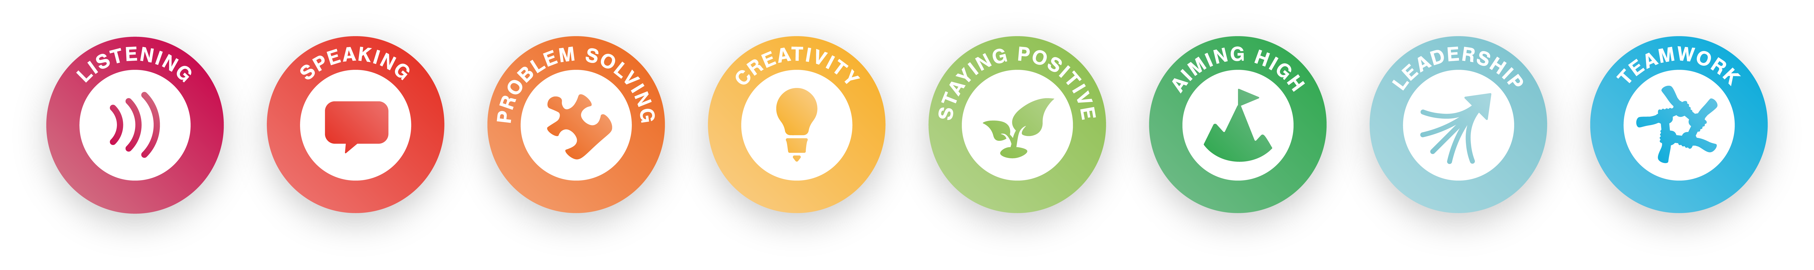

Students have up to four lessons a week of Building Blocks. This entails being with their tutor and TLA exploring activities to embed skills from the Skills Builder Partnership.

This is also a precious time for tutors and TLAs to touch base with the students on individual basis to ensure that they develop essential skills and improve their mental health, if and when, necessary.

The tutor uses the Online Skills Builder to record sessions which build on skills and experiences such as going on an Autumn walk, making a treasure map, recycling, visiting a public library, to only cite a few.

This will go towards the Skills Builder.

# Attendance

At Brook Green we believe that good school attendance gives young people the opportunity of success and helps develop skills for life. We believe it is vital that all children attend school every day unless there is an unavoidable cause like illness.

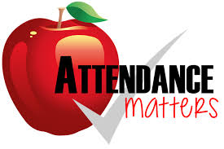**Routine is the key to success.**

**Here is a simple 5 point plan to try with the family**

* Going to school unprepared can be a major worry for children - help them by checking school bags the night before, packing P.E. bags and keeping an eye on their homework
* Tired children aren't punctual and find it hard to learn, so ensure your child has a sensible bed time
* Help them get into a regular routine and set an alarm at the same time every morning
* Make time for breakfast or send them in for breakfast at Tutor time there will be no stop off at the shops where they can get side tracked on the way to school and they won’t become tired during the mornings lessons
* Children can become unsettled if they have to go into school late and without their friends- getting them to school on time to meet friends prevents this.



**Tools for School**

.

**Home / School Book**

Every student is provided with a Home/School Book which has lots of useful information in it and has space for recording homework and any comments or notes from you or us.

We provide every student with a pencil case when they start with us. This is for them to use on a daily basis and if lost or broken, it needs to be replaced by parents or carers.

Students are also provided with a PE bag and a drink bottle which they are expected to use.

Basic guide for a pencil case:

- a pencil

- a rubber

- a black pen

- a small ruler

- colouring pencils

School Uniform

**Trousers**

Shirt

**Blazer**

**UNIFORM**

 Blazer Black blazer with logo.

Jumper Black v-neck (optional)

Shirt: White

Trousers: Black/Grey (but not denim / jeans or leggings) of

full length

Skirt: Black/Grey (Skirt to be knee-length)

Shoes: Black - flat or low heels (no logos, white

Or coloured trimmings)

Socks: Black/White/Grey (plain)

Tights: Black/Grey/Flesh-coloured (plain)

Tie: Brook Green school tie

[](https://www.google.co.uk/url?sa=i&rct=j&q=&esrc=s&source=images&cd=&cad=rja&uact=8&ved=2ahUKEwiAscigq_HbAhUqDMAKHfQ2DKIQjRx6BAgBEAU&url=https://www.mycutegraphics.com/graphics/tshirt-images.html&psig=AOvVaw1EGyuZSNANDqqbbac0J_aN&ust=15301027941)[](https://www.google.co.uk/url?sa=i&rct=j&q=&esrc=s&source=images&cd=&cad=rja&uact=8&ved=2ahUKEwiAscigq_HbAhUqDMAKHfQ2DKIQjRx6BAgBEAU&url=https://www.mycutegraphics.com/graphics/tshirt-images.html&psig=AOvVaw1EGyuZSNANDqqbbac0J_aN&ust=15301027941)

**P.E. Kit**

School team shirt

Black shorts

Black trainers

Wind

Fire

Earth

Water

Fire

Wind

Earth

Water

**Assessment**



We have a baseline assessment week at the start of each year, which allows us to look at progress across the curriculum and three data collection rounds in November, February and June. We then set targets from this information.

There are a number of parents’ evenings across the year when you can come in and meet your child’s subject teachers. Reports are written at different times depending on which year your child is in.

We will always get in contact and let you know, but if you want any information in between please let us know.

******Homework**  **After school activities**

Homework / own work at Key Stage Three is based on embedding Literacy and Numeracy skills which are the building blocks of our curriculum and also a Life Skills programme which we ask you to support us with at home.

Please follow the link on our school website for further information.

* brookgreen.org.uk/curriculum mathematics- homework policy
* brookgreen.org.uk/curriculum literacy – English and Literacy homework policy
* brookgreen.org.uk/curriculum home learning – subject words/high frequency words



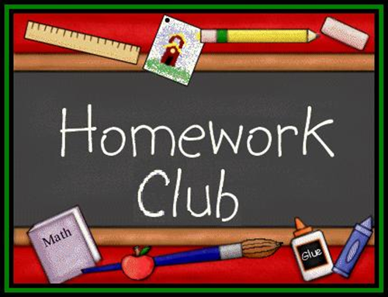

Thursday night is after school

activities night and they normally run from 3.15pm until 4.00pm.

You will receive letters home when

activities are due to start or a new activity is being run.

Unfortunately, transport is not provided for after school activities.

We also run a homework club on Wednesdays from 3.00pm - 4.00pm

**Support for parents**

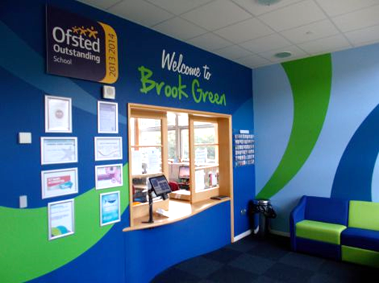

At Brook Green Centre for Learning, we pride ourselves on our communication in supporting, not only your child, but also parents and carers.

You can contact us at any point for information, advice or organising meetings by emailing: [brook.green.school@plymouth.gov.uk](mailto:brook.green.school@plymouth.gov.uk)

or phoning on 01752 773875

Mrs Sara Jordan: Headteacher and Safeguarding Lead

Mrs Holt: Deputy Headteacher

Mrs Marchand-Smith: KS3 Lead

Mrs Krac: Behaviour Manager and Safeguarding Team

Mrs Newcombe: Student Health and Wellbeing Lead and Safeguarding Team

Mrs Eglinton: Assistant Head

**Contacting us – the Tutor Team are:**

|  |  |  |  |  |  |  |  |  |  |  |  |  |  |  |  |  |  |  |  |  |  |  |  |  |  |  |
| --- | --- | --- | --- | --- | --- | --- | --- | --- | --- | --- | --- | --- | --- | --- | --- | --- | --- | --- | --- | --- | --- | --- | --- | --- | --- | --- |
| |  |  |  | | --- | --- | --- | | Tutor Group | Tutor | TLA | | 7JD | Miss Davies |  | | 7MP | Mrs Paganuzzi |  | | 8JSP | Mr Spree |  | | 8MD | Mr Dubiel |  | | 9RR | Miss Russell |  | | 9ABo  9PEA | Mr Bone  Ms Eastel |  | |  |  |  |  |  |

If you would like further information about anything covered in this leaflet, please contact Mrs Marchand - Smith at school on 01752 773875 or on the contact form on our website.

We update our website regularly with what’s going on at BGCfL – so check it out!



