BGCFL

MATHS DEPARTMENT

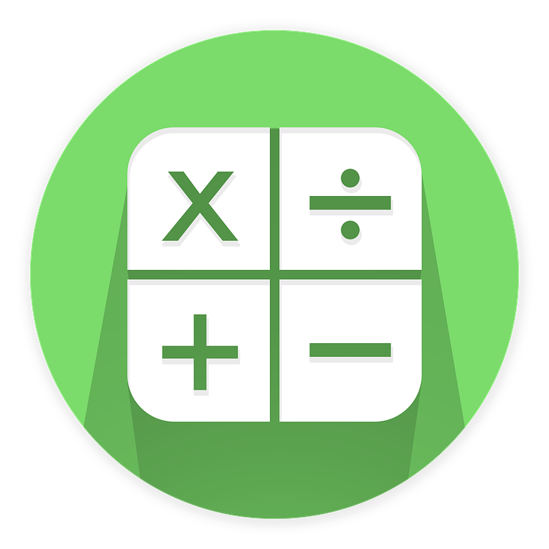

YEAR 9
SCHEME OF WORK

This scheme of work is to be used as a guide only. Sometimes due to unforeseen circumstances the class may be a week behind or sometimes may even a week ahead of schedule. The topics will still be covered in the same order.

Term 1Year 9

Number | Learning Objectives. | Resources.
Week 1 | Up to Stage 6: Add, multiply and divide on paper. | Play money.  Number lines.  Dice.  Cubes.  Counters.  Worksheets.  Test sheets.  ICT: My Maths, Twinkl and many more resources.
Week 2 | Stage 4: Recognise and use negative numbers in real life situations.
 | Stage 4: Order negative numbers.
 | Stage 4: Add and subtract negative numbers.
Week 3 | Stage 7: Add and subtract decimals to 2 decimal places.
 | Stage 7: Multiply and divide numbers to 2 decimal places.
Week 4 | Stage 7. Multiply any number by 10, 100 and 1000.
 | Stage 7: Divide any number by 10, 100 and 1000.
Week 5 | Stage 7: Multiply a 3 digit number by a 2 digit number.
 | Stage 7: Divide a 3 digit number by a 2 digit number.
Week 6 | Consolidation and end of term test.
Advice: Less able pupils may not complete all sections. They can concentrate on understanding number and simple addition and subtraction. Use SOW for years 7 and 8 if required.
Most able pupils can progress further by solving problems involving 4 or more digits including several decimal places.
Many activities can be taught as starters or games at the end of each lesson.

Term 2 Year 9

Shape and Measure | Learning Objectives. | Resources.
Week 1 | Stage 3: Reflect simple shapes in a mirror line. | Number lines.  Rulers.  Metre rules.  Pairs of compasses.  Angle measures.  Trundle wheels.  Weighing scales.  Measuring jugs.  Maps.  Textbooks.  Worksheets.  Plastic shapes.  Test sheets.  ICT: My Maths, Twinkl and many more resources.
 | Stage 3: Recognise symmetry in 2D shapes.
 | Stage 4: Know the order of rotational symmetry of a shape.
Week 2 | Stage 6: Enlarge shapes by a positive whole scale factor.
 | Stage 6: Level 6: Enlarge shapes by a negative whole scale factor.
Week 3 | Stage 5: Find areas of shapes made from rectangles.
 | Stage 6: Find the volume of a cuboid.
Week 4 | Stage 4: Identify and name all parts of a circle.
 | Stage 6: Know the formulae for circumference and area of a circle.
Week 5 | Stage 4: Identify congruent shapes.
 | Stage 4: Know how to tessellate a 2D shape.
 | Stage 4: Draw nets of 3D shapes.
Week 6 | Consolidation and end of term test.
Advice: Less able pupils may not complete all sections. They can concentrate on understanding simple reflection or finding area by counting squares etc. See SOW for year 7 and 8 if required.
Most able pupils can progress further by enlarging a shape by a fractional scale factor or volumes of more complicated compound shapes etc.
Many activities can be taught as starters or games at the end of each lesson.

Term 3 Year 9

Number | Learning Objectives. | Resources.
Week 1 | Stage 4: Solve simple ratio and proportion problems. | Play money.  Number lines.  Dice.  Cubes.  Counters.  Worksheets.  Test sheets.  ICT: My Maths, Twinkl and many more resources.
 | Stage 4: Find best buys using ratio.
 | Stage 5: Split an amount into a given ratio.
Week 2 | Stage 5: Convert fractions in percentages and decimals.
 | Stage 5: Convert percentages into fractions and decimals.
 | Stage 5: Convert decimals into fractions and percentages.
Week 3 | Stage 6: Find a fraction of a given amount.
 | Stage 6: Find a percentage of a given amount.
Week 4 | Stage 4: Add and subtract fractions with common denominator.
 | Stage 4: Add and subtract fractions with different denominators.
Week 5 | Stage 6: Recognise all square numbers up to 15 x15.
 | Stage 6: Can calculate simple powers of whole numbers.
Week 6 | Consolidation and end of term test.
Advice: Less able pupils may not complete all sections. They can concentrate on understanding simple fractions, percentages etc.
Most able pupils can progress further by solving problems involving powers and roots etc.
Many activities can be taught as starters or games at the end of each lesson.

Term 4

Data Handling | Learning Objectives. | Resources.
Week 1 | Stage 3: Draw frequency diagrams. | Flip charts.  Textbooks.  Worksheets.  Test sheets.  ICT: My Maths, Twinkl and many more resources.
 | Stage 4: Interpret frequency diagrams.
Week 2 | Stage 4: Draw and draw conclusions from scatter diagrams.
 | Stage 4: Discuss correlation on scatter diagrams.
Week 3 | Stage 7: Construct pie charts.
 | Stage 7: Interpret pie charts.
Week 4 | Stage 6: Find mode and median of a set of data.
 | Stage 6: Find the mean of a set of data.
 | Stage 6: Compare 2 sets of data using mode, median, mean and range.
Week 5 | Stage 6: Collect continuous data using equal class intervals.
 | Stage 6: Interpret and analyse continuous data.
Week 6 | Consolidation and end of term test.
Advice: Less able pupils may not complete all sections. They can use simple fractions for pie charts and use discrete data.
Most able pupils can progress further by collecting and analysing more in depth data and test hypotheses.
Many activities can be taught as starters or games at the end of each lesson.

Term 5

Shape | Learning Objectives. | Resources.
Week 1 | Stage 6: Name quadrilaterals. | Sets of plastic shapes.  Lesson templates.  Textbooks.  Worksheets.  Follow me cards.  Flip charts.  Mirrors.  Pairs of compasses.  Angle measures.  ICT: My Maths, Twinkl and many more resources.
 | Stage 6: Know properties of different quadrilaterals.
Week 2 | Stage 7: Find exterior angles of polygons.
 | Stage 7: Find interior angles of polygons.
Week 3 | Stage 7: Identify and evaluate corresponding and opposite angles on parallel lines.
 | Stage 7: Identify and evaluate alternate angles on parallel lines.
Week 4 | Stage 5: Measure bearings accurately
 | Stage 5: Draw bearings accurately.
Week 5 | Stage 4: Draw simple shapes on isometric paper.
 | Stage 6: Can recognise plans and elevations from isometric drawings.
Week 6 | Consolidation and end of term test.
Advice: Less able pupils may not complete all sections. They can concentrate on identifying polygons and quadrilaterals etc.
Most able pupils can progress further by solving more complicated real life problems involving parallel lines etc.

Term 6

Algebra | Learning Objectives. | Resources.
Week 1 | Collect like terms. Substitution. | Play money.  Number lines.  Dice.  Cubes.  Counters.  Worksheets.  Test sheets.  ICT: My Maths, Twinkl and many more resources.
Week 2 | Solving linear equations with one step.  Solving linear equations with 2 steps.
Week 3 | Probability. Language we use.  Probability scale.  Finding probabilities.
Week 4 | Probability space diagrams.
Week 5 | Recap all work.To include exam question practice.
Week 6 | Consolidation and end of term test.
There will be 3 end of term exams that pupils will take according to their abilities. Therefore all revision can be set at the level of individual. pupil.

