Year 10 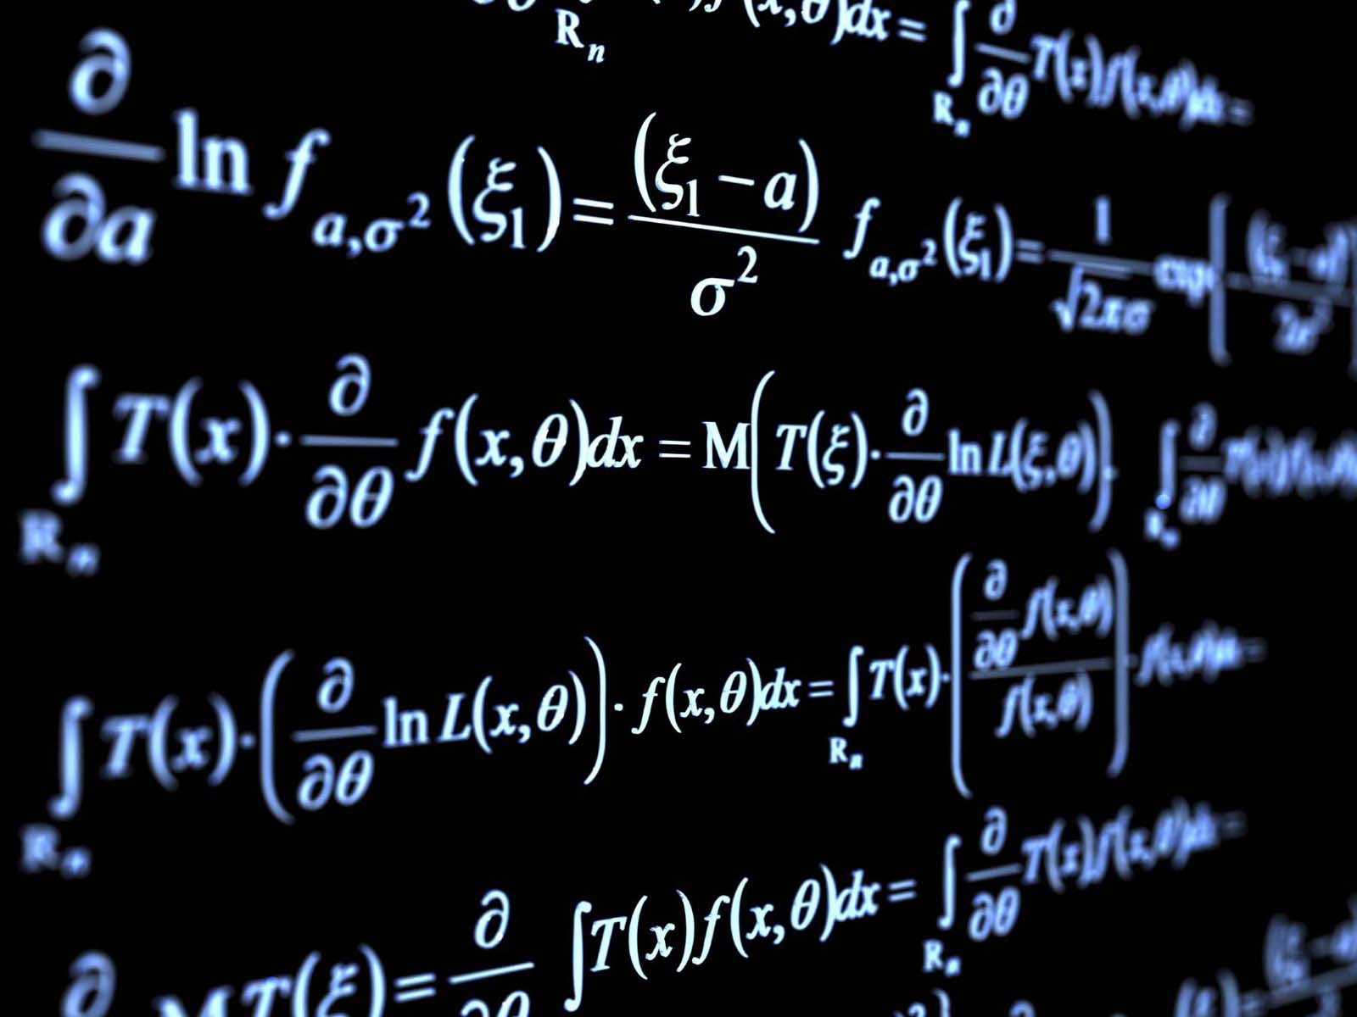
GCSE GROUP SCHEME OF WORK
This scheme of work is to be used as a guide only. Sometimes due to unforeseen circumstances the class may be a week behind or sometimes may even a week ahead of schedule. The topics will still be covered in the same order.
Term 1
Week 1  Number: Basic number. | - Integers and place Value.  - Using Decimals up to 2 places, to include addition and subtraction.  - Rounding to decimal places and sig figs.  - Estimating answers.
Week 2  Number: Basic number. | - Multiplication up to 3 figure numbers by 3 figure numbers.  - Division.  - Multiplication times 10 including decimals.  - Division by 10 including decimals.
Week 3  Negative numbers. | - Introduce negative numbers and give real life examples.  - Use the four operations using negative numbers.
Week 4  Indices. | - Introduce square numbers and square roots.  - Multiplication and division laws of indices including brackets.
Week 5  BIDMAS. | - Work out difficult calculations using BIDMAS. To include decimal places, rounding and sig figs.
Week 6  Review week. | - Review all topics covered this term. These topics are essential to the future progress of students.
Week 7  Test. | - End of term test.  - End of term activities.

Term 2
Week 1  Percentages. | - Understanding percentages.  - Writing one number as a percentage of another.  - Percentages of an amount without a calculator. 25% 50% etc.  - Percentages of an amount with a calculator
Week 2  Fractions. | - Introduction of simple fractions including non-unitary numerators.  - Equivalent fractions.  - Addition and subtraction of fractions.  - Multiplication and division of fractions.
Week 3  Percentage, fractions and decimals. | - Know why and when we use each of the three proportions.  - Be able to change from percentage to decimal or fraction and vice versa.
Week 4  Ratio and proportion. | - Using ratios.  - Dividing into a given ratio.  - Best buys.  - Proportional ingredients.
Week 5  Multiples, factors and prime numbers. | - Find multiple of any number.  - Find all the factors of any number.  - Identify prime numbers.
Week 6  Review week | - Review all topics covered this term. Once again these topics are fundamental for the GCSE exams.
Week 7  Test | - End of term test to include material from term 1.  - Christmas maths activities.

Term 3
Week 1  Algebra. | - Simplifying expressions.  - Multiplying and dividing Letters.  - Expanding brackets.  - Factorising.
Week 2  Equations. | - Solving basic equations.  - Solving two step equations.  - Solving equations involving brackets.
Week 3  Equations. | - Make an algebraic equation.  - Using algebra to solve problems such as areas of shapes.
Week 4  Formulae. | - Writing formulae.  - Substitution.  - Rearranging formulae.
Week 5  Functions. | - Use functions to find inputs and outputs.
Week 6  Review and test week. | - Review all topics covered this term.  - End of term test. This test will cover this terms work only.  - End of term activities.

Term 4
Week 1  Tables and charts. | - Design and use data collection sheets.  - Bar charts and pictograms.
Week 2  Pie charts. | - Understand that pie charts show proportion.  - Draw a simple pie chart.  - Draw a more complicated pie chart.  - Anylse pie charts.
Week 3  Scatters graphs. | - Draw and interpret scatter graphs.  - Describe correlation.  - Draw a line of best fit.  - Identify outliers.
Week 4  Line Graphs. | - Plot coordinates in all four quadrants.  - Draw lines such as x = 4 and y = -2 etc.  - Draw lines such as y = 2x or y = x+1 .
Week 5  Line Graphs. | - Plot any straight line graph. Y = mx + c  - Find the equation of a straight line.
Week 6  Review and test week. | - Review all topics covered this term.  - End of term test.  - End of term activities.

Term 5
Week 1  Probability. | - Be able to write probabilities as fractions decimals or percentages.  - Find the probability of a given event.  - Know that the probabilities of mutually exclusive events always = 1.
Week 2  Probability. | - List the outcomes of two or more events.  - Use sample space diagrams to list outcomes of more complicated events.  - Use sample space diagrams to find probabilities.
Week 3  Perimeter | - Workout the perimeters of rectangles, triangles and other shapes.  - Workout the perimeters of compound shapes.
Week 4  Area. | - Workout the areas of rectangles, triangles and other shapes.  - Workout the area of compound shapes.
Week 5  Volume. | - Workout the volume of rectangles, triangles and other shapes.  - Workout the volume of compound shapes.
Week 6  Review and test week. | - Review all topics covered this term.  - End of term test.  - End of term activities.

Term 6
Week 1  Circles | - Recognise terms used in circle work.  - Discover pi.  - Find the circumference of a circle.
Week 2  Circles | - Find the area of a circle.  - Find the perimeter and area of a semicircle and quarter circle.
Week 3  Symmetry | - Draw reflections in the x and y axis.  - Work out the order of rotational symmetry.
Week 4  Review week | - Review all topics covered this term.
Week 5  Review and test week | - Review all topics covered this year.  - End of year test.  - End of term activities.
Week 6  Maths activities week | - End of year maths activities.
Week 7  Activities week | - Activities week.

