Yr 10 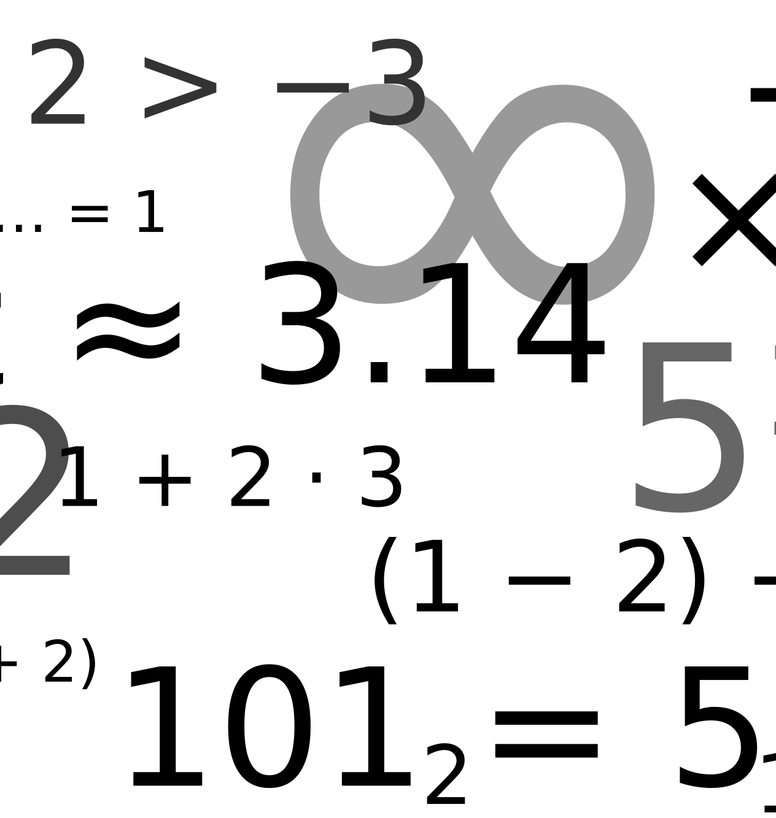
ELP GROUP SCHEME OF WORK 2016-2017
Term 1
Week 1  Introduction to Whole number | - Place value.  - Large numbers.  - Ascending / descending numbers.
Week 2  Introduction to Whole number | - Write numbers in words and vice versa.  - Count forward and backwards in steps of 2, 5 and 10.
Week 3  Introduction to Whole number | - Count forward and backwards in steps of 50 and 100.
Week 4  Working With Whole number | - Round numbers to nearest 10.  - Round numbers to nearest 100.  - Round numbers to nearest 1000.
Week 5  Working With Whole number | - Addition in real life.  - Subtraction in real life.
Week 6  Working With Whole number | - Multiplication in real life.  - Division in real life.
Week 7  Recap and end of term activities | - Recap and end of term activities.

Term 2
Week 1  Working with Fractions | - Identifying fractions.  - Identifying non unit fractions.
Week 2  Working with Fractions | - Identify whole numbers.  - Find the fraction of an amount.
Week 3  Working with Fractions | - Find the non unit fraction of an amount.
Week 4  Using money | - Making amounts of money.  - Adding up a shopping list.  - Rounding money to nearest pound.
Week 5  Using money | - Working out change.
Week 6  Using money | - Recap of all money work.
Week 7  Recap and end of term activities | - Recap and end of term activities.  - Christmas activities.

Term 3
Week 1  Working with 2D and 3D shapes | - Recognising polygons.  - Recognising 3D shapes.
Week 2  Working with 2D and 3D shapes | - Draw lines of symmetry.  - Draw reflections in a mirror line.
Week 3  Working with 2D and 3D shapes | - Compare shapes.  - Identify properties of 2D shapes.  - Identify properties of 3D shapes.
Week 4  Working with 2D and 3D shapes | - Identifying 3D shapes from 2D pictures.  - Draw 3D shapes on isometric paper.
Week 5  Working with 2D and 3D shapes | - Drawing nets.  - Making objects from nets.
Week 6  Review week | - Recap and end of term activities.

Term 4
Week 1  Units of measurement | - Know units of length.  - Know units of mass.  - Know units of capacity.
Week 2  Units of measurement | - Estimate length.  - Estimate mass.  - Estimate capacity.
Week 3  Units of measurement | - Accurate measure length.  - Accurate measure mass.  - Accurate measure capacity.
Week 4  Working with angle and position | - DescrIbe position.  - DescrIbe angles.
Week 5  Working with angle and position | - Describe and plan a route.  - Directions on compass.
Week 6  Review week | - Recap and end of term activities.

Term 5
Week 1  Data Handling | - Data Handling Investigation.
Week 2  Data Handling | - Data Handling Investigation.
Week 3  Data Handling | - Interpreting information from tables and charts.  - Interpreting information from 2 way tables and charts.
Week 4  Data Handling | - Comparing information from tables and charts.  - Comparing information from 2 way tables and charts.
Week 5  Finishing Off | - Making sure everything is finished and collated.
Week 6  Review week | - Recap and end of term activities.

Term 6
Week 1  Number | - Start to look at % and fractions applied to money off offers.  - Trip to Tesco / Matalan to see offers.
Week 2  Number | - Project looking at the cost of a summer holiday
Week 3  Number | - Continue with project.
Week 4  Outdoor Week | - Various numeracy activities outdoors.
Week 5  Activities week | - Activities week
Week 6  Activities week | - Activities week

